AWS IAM User Creation and Giving permission
Objectives:
1. To understand the purpose of IAM in AWS
2. To create a dedicated IAM user
3. To enable console access for the user.
4. To set a strong password
5. To attach a permission policy
6. To restrict access using least privilege
7. To review user configuration before creation
8. To retrieve and save user credentials
9. To verify successful login
10. To validate permission boundaries

Step 1 Open IAM Users — Navigate to Create User

● In the AWS Management Console, search for IAM and open the IAM dashboard.
● From the left sidebar under Access Management, click Users.
● The Users list is currently empty — No resources to display.
● Click the Create user button in the top-right corner to begin adding a new IAM user.

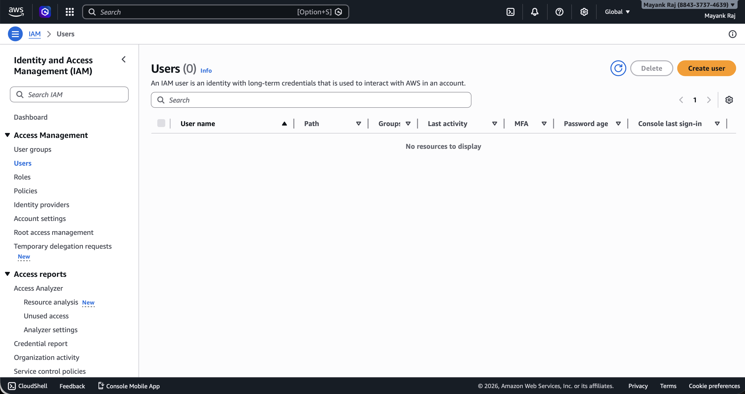
Step 2 Specify User Details — Set Username and Password

● On the Specify user details page, enter the username
● Check 'Provide user access to the AWS Management Console' to enable console login.
● Under Console password, select Custom password and enter the desired password.
● Leave 'Users must create a new password at next sign-in' unchecked so no reset is required.

Step 3 Set Permissions — Attach AmazonS3FullAccess Policy

● On the Set permissions page, select Attach policies directly as the permissions option.
● In the search box, type 's3' to filter the policy list
● Check the box next to AmazonS3FullAccess (AWS managed policy) to select it.
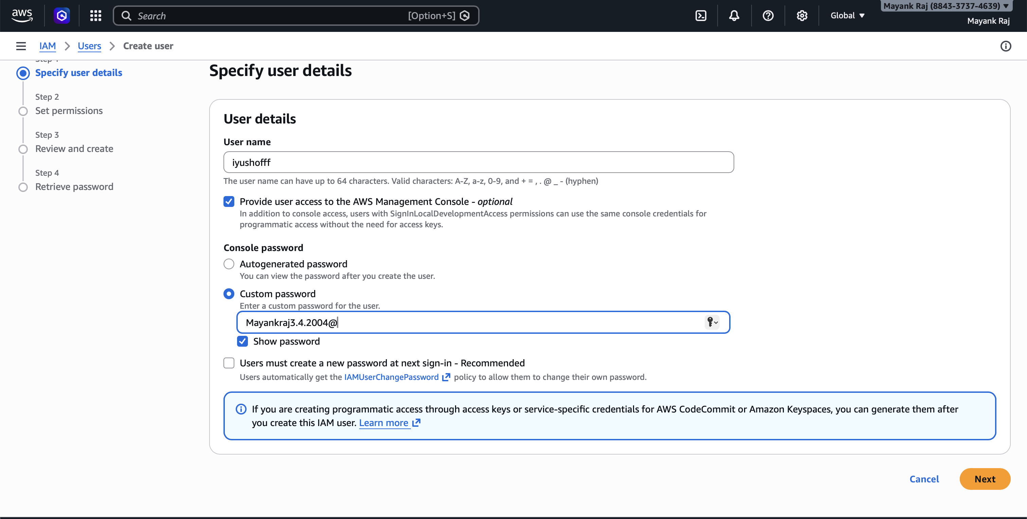
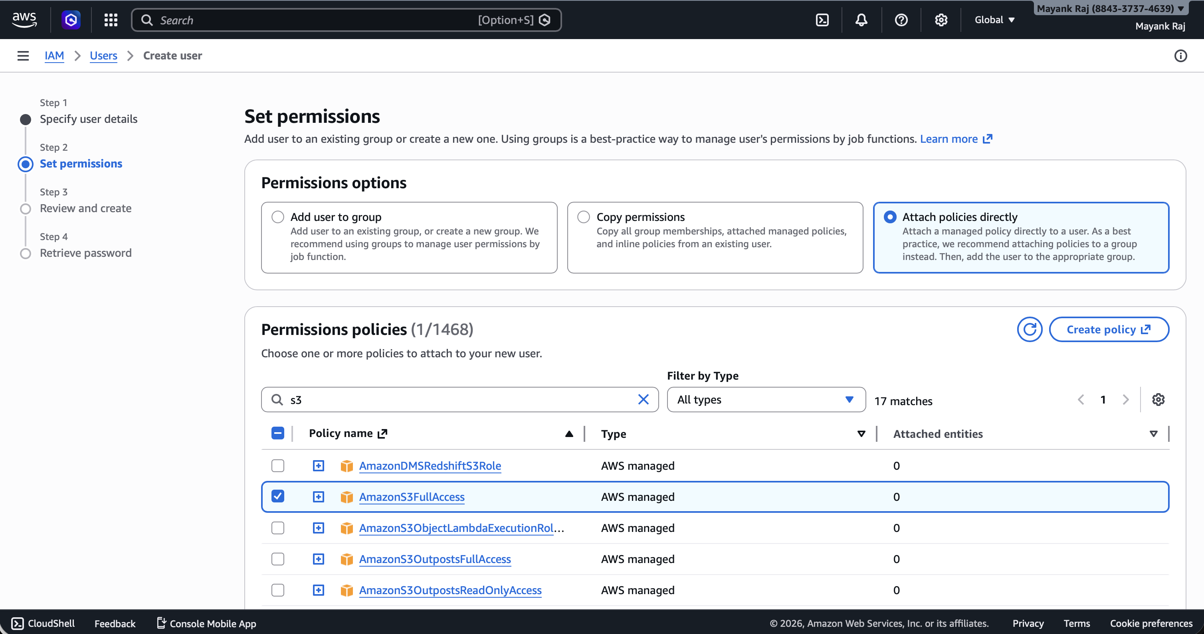
● This grants the user full read and write access to all S3 buckets and objects.
● Click Next to continue to the review screen.

Step 4 Review and Create — Confirm All Settings

● The Review and create screen shows a complete summary of the new user's configuration.
● Click Create user to finalize the IAM user creation.

Step 5 User Created — Retrieve Console Sign-In Credentials

● A green banner confirms: User created successfully.
● The Retrieve password screen shows the Console sign-in details for the new user.

Step 6 IAM User Sign-In — Access the AWS Console
• Navigate to the IAM user sign-in page (the Console sign-in URL).
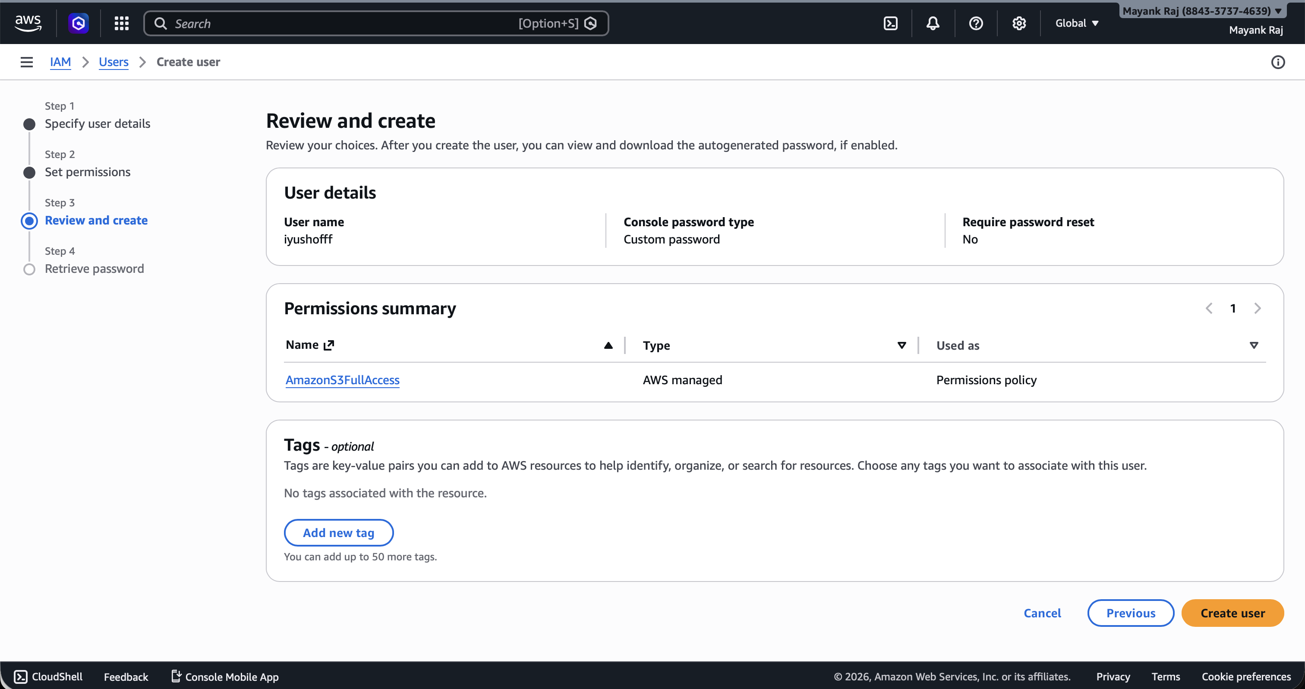
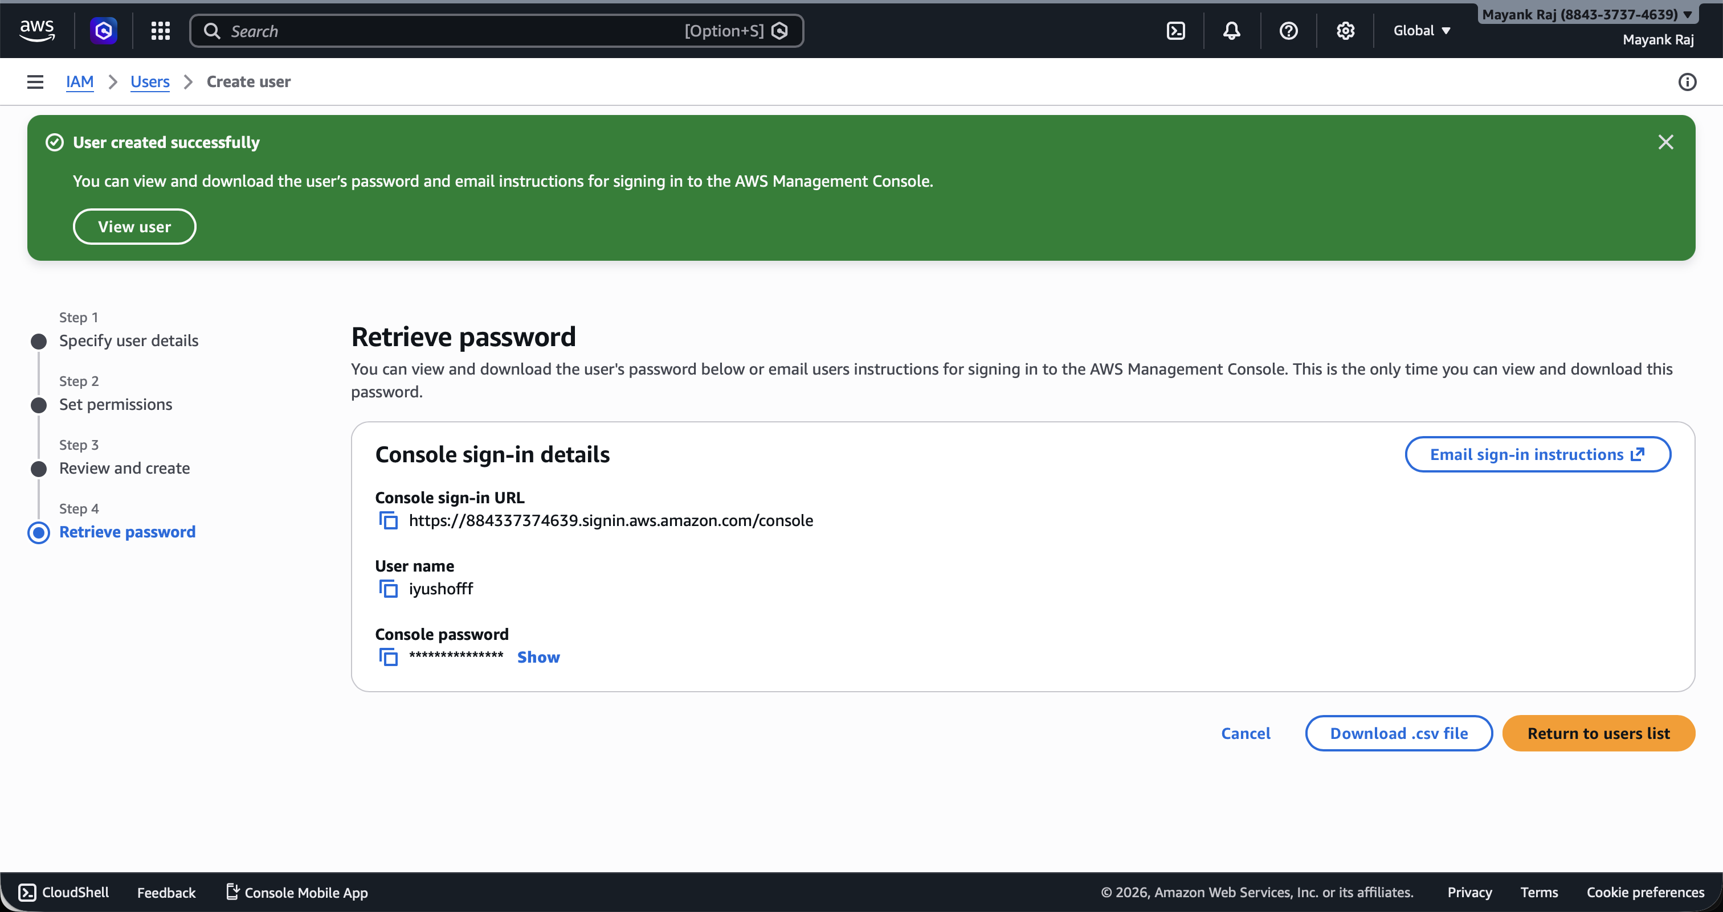
• Enter the IAM username and the password set during user creation.
• Click Sign in to authenticate as the new IAM user.

Step 7 Console Home — Logged In as IAM User
• After signing in, the AWS Management Console Home is displayed for the IAM user
• An access error appears for servicecatalog:ListApplications, which is expected — the user only has AmazonS3FullAccess and no broader permissions.
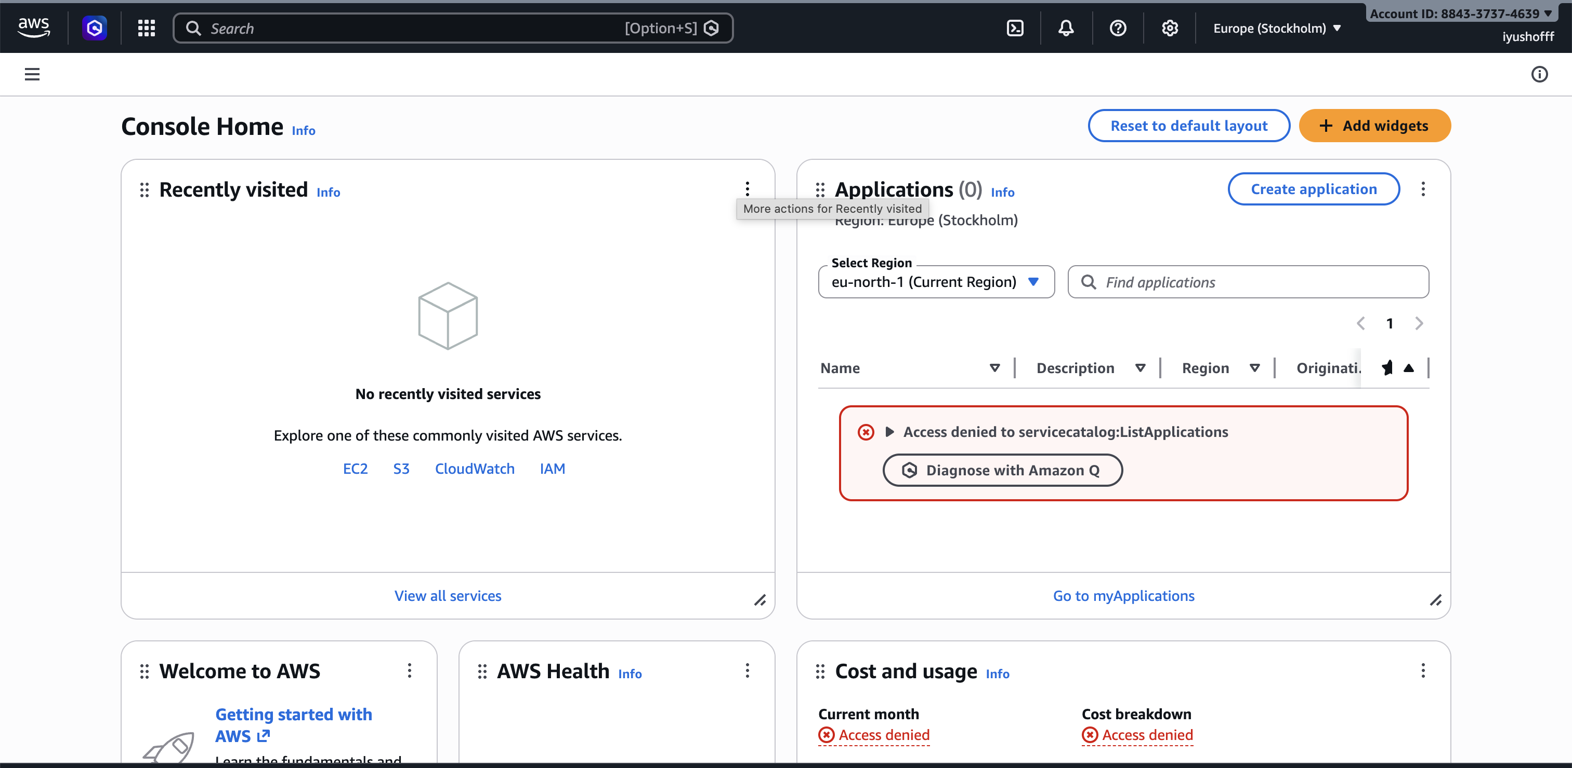
• The user can now navigate to S3 to perform authorized actions.

